ESCALATE v3 UI User Guide

## 

## **Table of Contents**

1. Introduction
2. Account Creation/Login
   1. Account Creation
   2. Login
3. Main Menu
   1. User Profile/Logout
   2. Select Lab
   3. Model Dropdown
   4. Experiment Dropdown
4. Models
5. Create New Experiment Template
6. Experiment Creation
   1. Manual Experiment Creation
   2. Automated Experiment Creation
7. Experiment Queue/Completed Experiment List
   1. Edit Experiment
   2. Outcome
   3. Reagent Preparation
   4. Delete
8. Experiment Detail Editor
9. Escalation
10. References

## 

## 

## 

## 

## 

## **1. Introduction**

The purpose of this document is to instruct new users through the ESCALATE v3 application. Use the links associated in the table of contents above and throughout the user guide to quickly navigate through this document. For a detailed explanation of the API reference the ESCALATE v3 API User Guide.

## **2. Account Creation/Login**

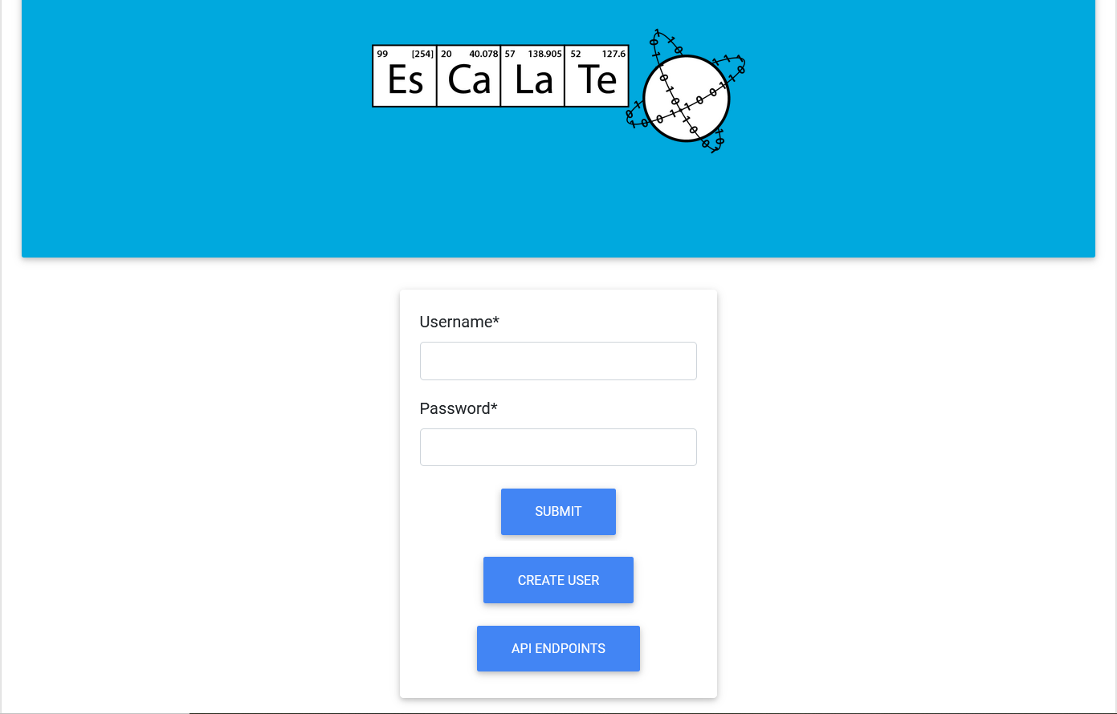

### 2a. Account Creation

Navigate to the login page (localhost:8000 by default on local machine installations). Select the “Create User” button at the bottom of the page. This will cause the user creation form to populate the page. Fill in the required fields, marked with an (*). Passwords can’t be too similar to personal information, must contain at least 8 characters, can’t be entirely numeric, and can’t be commonly used passwords.  
  
 Below the required fields are personal information fields. These fields will be used to pre-populate the user profile. These fields can be added/edited at any time from the profile dropdown at the top of the main page.

Once a user has filled out the required fields and any personal information they would like to add at this point in time they can select the “Submit” button to process the form and create the user account.

### 2b. Login

At the login screen, fill in the username and password associated with an account and select “Submit”. Users with valid credentials will be redirected to the main menu. If you do not remember your credentials to log into the application please reach out to the administrator that is managing the ESCALATE application.

## **3. Main Menu**

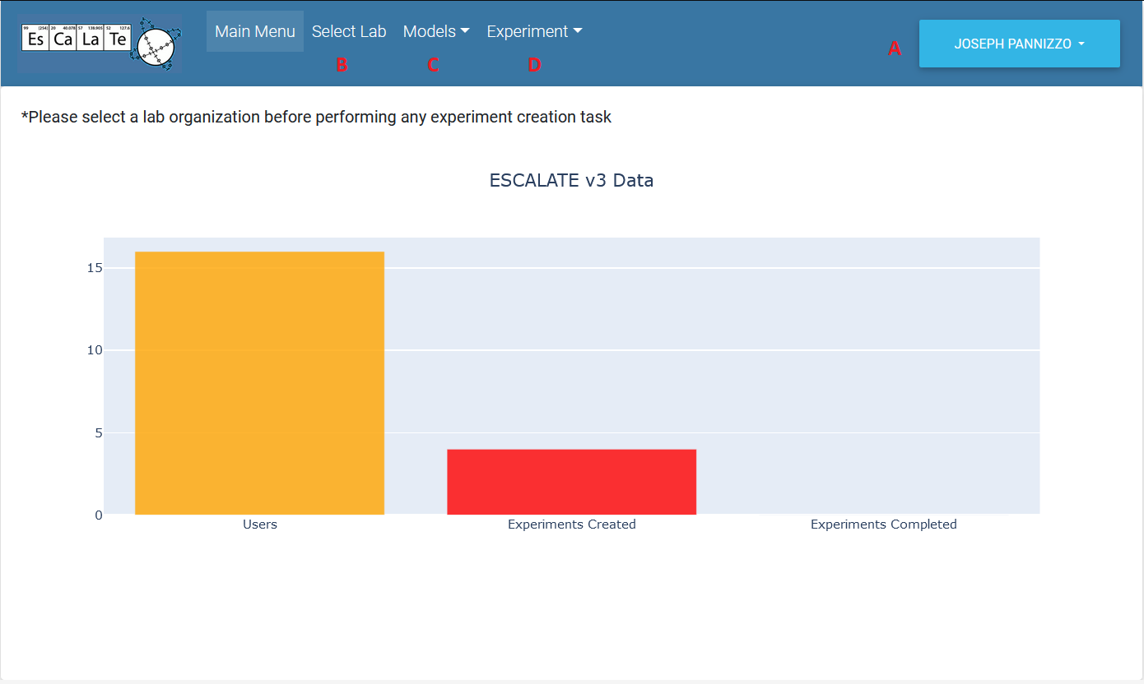

*Dropdowns are labeled according to the sections below*

### 3a. User Profile/Logout

Selecting your name in the top right corner of the application will provide a “Profile” and “Logout” options from the dropdown menu. Selecting “Logout” will log out of the application and redirect you to the login page. Selecting “Profile” will bring up your personalized user profile where you can see and edit personal information, add an image, and update lab associations. To join/leave a lab you must provide an organizational password that should be provided by that lab's administrator.

### 3b. Select Lab

Lab selection is required for any experiment creation task. Labs will need to be pre populated via the API and you will need to have joined a lab through the user profile before a lab can be selected. Press the “Select Lab” button at the top of the main menu. This will navigate you to the lab selection form. Select the appropriate lab from the drop down menu and confirm the selection by clicking “Select Lab”.

### 3c. Model Dropdown

This dropdown provides a list of models that can be searched over to find specific information on the following model instances:

* Material
* Vessel
* Inventory
* Inventory Materials
* Actor
* Organization
* Person
* Systemtool
* Systemtool Type
* Material Type
* Status
* Tag
* Tag Type
* Udf def
* Edocument

More information on the available data within these models can be found in the Model section.

### 3d. Experiment Dropdown

The experiment dropdown menu contains the main functionality of the UI application. Within this dropdown you can access experiment template creation, experiment instance creation, the experiment queue, the completed experiment list, and access to the escalation graphical software. This functionality will allow you to create, edit, delete and visualize experiments that will better suit your functional needs. More detailed information will be provided in subsequent sections.

## **4. Models**

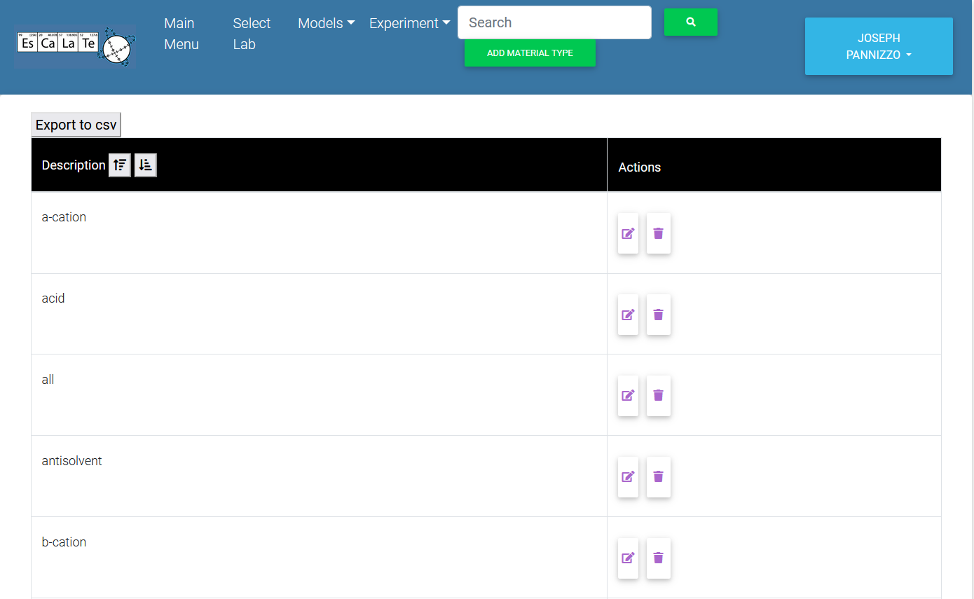

The models form allows users to search exposed models to find detailed information on any specific instance of that model. To search for a specific instance of a model select the model you would like to search through from the Model dropdown menu. Initially all instances of that model will be displayed in a list format. Results can be narrowed by using the search bar at the top of the page. Any instances that need to be removed from the table can be deleted using the trash can button located in the rightmost column of the table. Any instance can be edited by selecting the pen and paper button in the rightmost column of the table and a model edit form will be shown similar to the image below. The information available to edit will change depending on the model instance being edited. Submit any altered information for a specific model instance to save changes to the database.

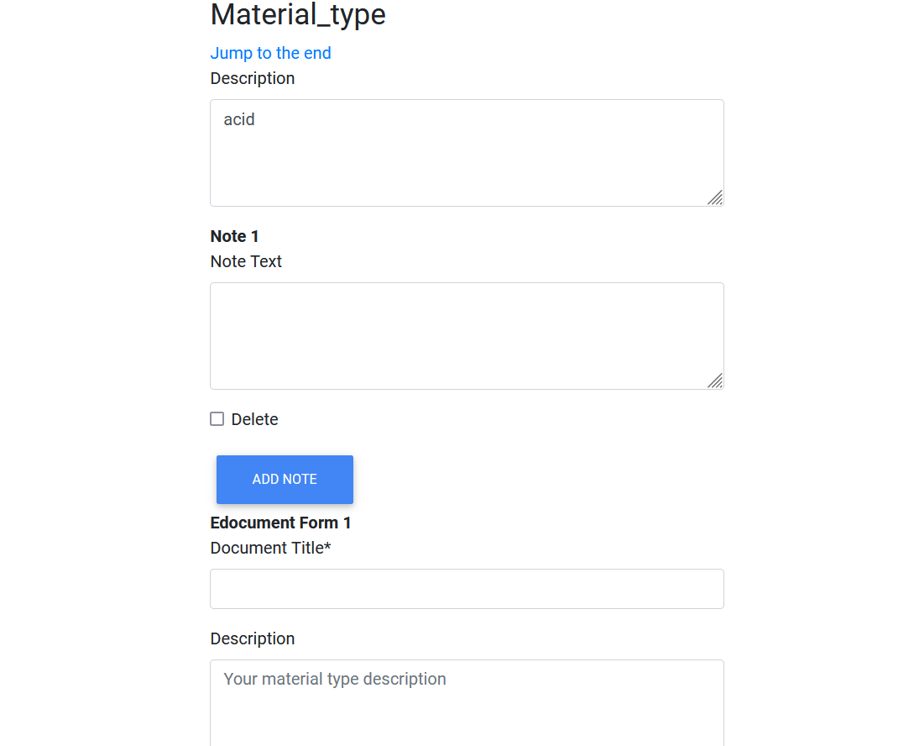

## **5. Create New Experiment Template**

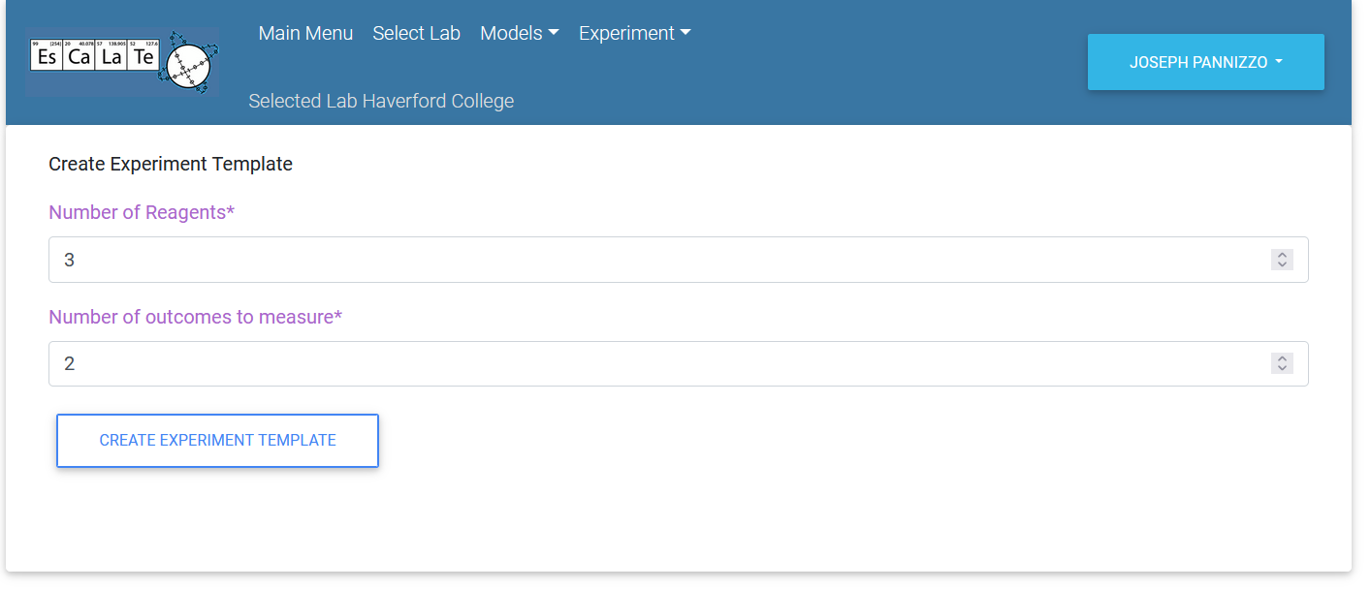

The UI allows for creation of an experiment template. This template is associated with particular reagents, outcomes, and a sequence of actions corresponding to an experimental procedure. Once created, the template can be reused over and over for specific experiments, and the specific parameters (e.g. materials in the reagents, concentrations, volumes, temperatures, vessel) can be changed from experiment to experiment.

The form shown above will be displayed when first accessing the experiment template creation page. This form allows you to declare the number of reagents needed to perform the experiments that utilize this template, as well as, the number of outcomes to measure for said experiment. Once those parameters are defined, click the “Create Experiment Template” button to bring you to the next form; defining the experiment template itself.

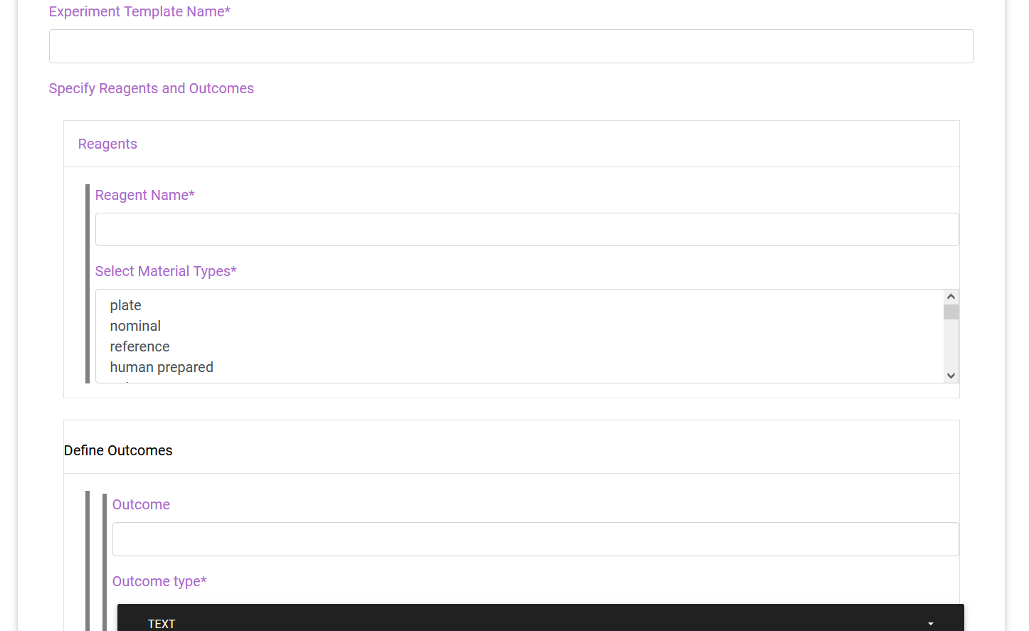

The text box at the top of the form will allow you to name the experiment template. This will be selected when creating experiment instances through the experiment creation process. Below that are the reagent and outcome sections. The number of reagents and outcomes correspond to the amount defined in the previous form. Reagent names are defined in the text box provided and their material type is selected from the list below each text box. If there are missing material types in the list they can be added via our API endpoint MaterialType. (*A full list of our exposed API endpoints can be found at localhost:8000/api/ for local installations*) Below reagent is the outcome section. Here you can define the name of each outcome that will be observed as well as the data type for each outcome. Once those are filled out you can select the “Submit” button at the bottom of the page to finalize the template and begin using it in the experiment creation process.

## **6. Experiment Creation**

Manual and Automated experiments can be created via the “Create Experiment” selection from the experiment dropdown menu. Once this is selected you will be redirected to the experiment template selection form. This form will allow you to select an experiment template that was defined prior to running this experiment instance as outlined in the section above. Manual and automated experiments can be run simultaneously, however, for the sake of simplicity we will describe each individually.

Upon completing the creation of an experiment the user will be prompted with a confirmation screen similar to the one below. There will be buttons/links to the experiment details, reagent preparation, and outcome forms for the experiment that was created. These forms will be detailed in the Experiment Queue/Completed Experiment List.

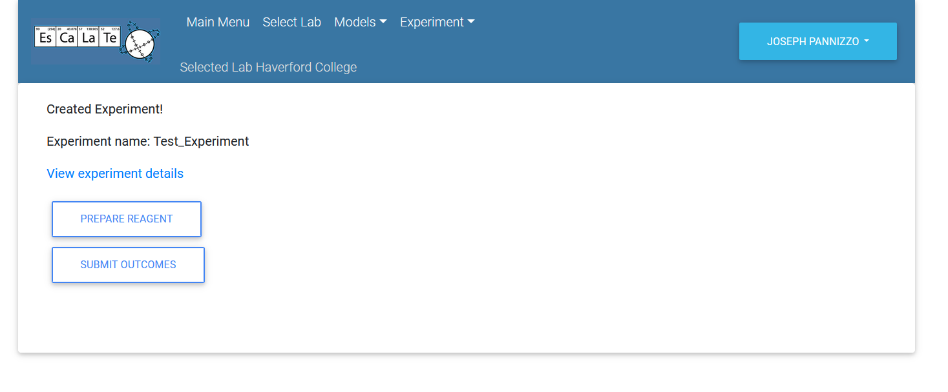

### 6a. Manual Experiment Creation

Manual experiments are one where the user specifies all compositions and other parameters. At the experiment template selection form, select the experiment template you would like to use, as well as, the number of manual experiments you would like to perform. To submit this form, click the “Select Template” button.

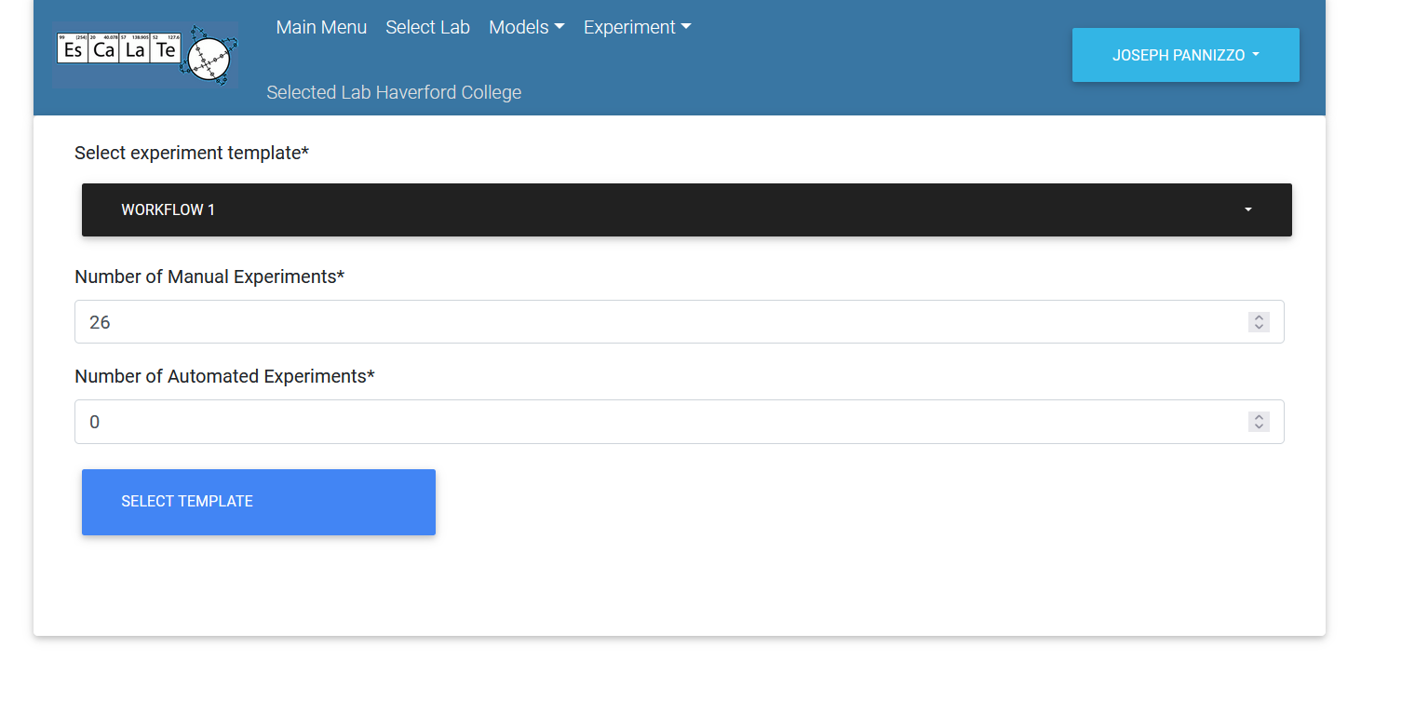

This will redirect you to the manual experiment specification form. At the top of the screen you will be required to name the experiment instance. Below that, there is a hyperlink that downloads a blank excel file associated with the experiment template being run. This excel file can be defined and customized via our API.(*A full list of our exposed API endpoints can be found at localhost:8000/api/ for local installations*) That file is to be filled out with the corresponding experimental information and reuploaded using the “Browse” button provided on the page.

Below the manual file upload will be a list of reagents associated with the experiment template. The desired concentrations for each chemical within the reagent should be populated; the unit of measurement by default is molarity (moles/Liter) and should be updated if it is different from the default. **Note:** The concentration values must be non-negative numbers. Technically, the concentration value for a solvent is meaningless and therefore can be left as 0.0 M, but the experiment creation process will function as long as any non-negative number is entered and the values for solvent concentration will simply be ignored.

The final section corresponds to experiment parameters such as the vessel being used and the desired dead volume, i.e., excess volume in the bottom of the vessel that cannot be pipetted out or otherwise serves as a safety margin . Select a vessel from the dropdown provided. If a vessel is not available it can be added by accessing the Vessel model via our API.(*A full list of our exposed API endpoints can be found at localhost:8000/api/ for local installations*) The dead volume of the vessel is defaulted to 4000 uL and can be updated in the text box provided.

### 6b. Automated Experiment Creation

Automated experiment creation uses an algorithm to sample random concentrations of the solutes within the convex hull defined by the specified reagents in the experiment creation form. See doi i:10.1021/acs.jchemed.0c01456 for an explanation of this process. This experiment creation process, unlike manual experiment creation, does not rely on a file upload. Functionally, the rest of the experiment creation form is the same as detailed within the manual experiment creation process.

At the experiment template selection form, select the experiment template you would like to use, as well as, the number of automated experiments you would like to perform. To submit this form, click the “Select Template” button.

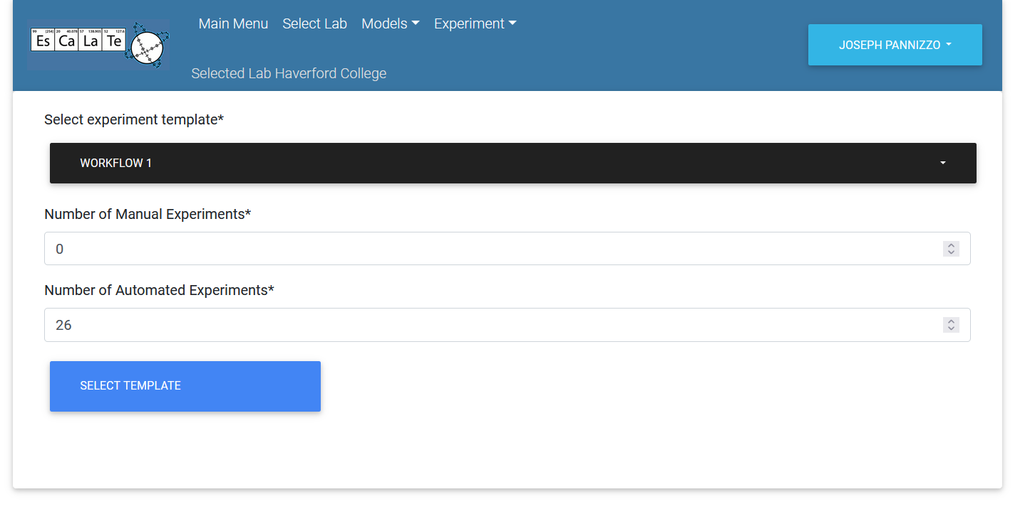

This will redirect you to the automated experiment specification form. At the top of the screen you will be required to name the experiment instance. Below this will be a list of reagents associated with the experiment template. The desired concentrations for each chemical within the reagent should be populated and the unit of measurement should be updated if it is not being measured in moles. **Note:** All non-solvents should contain a non-zero, positive number.

The final section corresponds to experiment parameters such as the vessel being used and the desired dead volume. Select a vessel from the dropdown provided. If a vessel is not available it can be added by accessing the Vessel model via our API.(*A full list of our exposed API endpoints can be found at localhost:8000/api/ for local installations*) The dead volume of the vessel is defaulted to 4000 uL and can be updated in the text box provided.

## **7. Experiment Queue/Completed Experiment List**

Both the experiment queue and completed experiment list operate similarly. They can both be accessed from the experiment dropdown at the top of the page. The experiment queue tracks pending and running experiments while the completed experiment list tracks finished experiments. **Note:** Invalidated experiments will not be tracked by either list but can be accessed via the API. Experiments that are deleted are marked as invalid and are not removed from the database.

### 7a. Edit Experiment

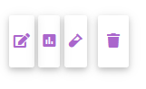

Marked with a pen and paper, a user can edit parameters, change the status of an experiment, upload edocuments, and change the priority of an experiment. An in depth explanation of this experiment detail editor can be found in the next major section Experiment Detail Editor.

### 7b. Outcome



The outcome section is used at the completion of an experiment to provide results relevant to that experiment instance. The outcome form provides a file download that can be populated and re-uploaded using the file browser within the outcome form. Any relevant files, images, spectroscopic results,, etc. can be uploaded using the second file browser below the outcome upload to attach any associated information relevant to the completed experiment. Once the relevant files are uploaded select the “Submit” button to upload the files to the database. Custom outcome files can be created through our Outcome API endpoint and will be associated with the relevant experiment template.(*A full list of our exposed API endpoints can be found at localhost:8000/api/ for local installations*)

### 7c. Reagent Preparation



Reagent preparation is used to report the actual values of the chemicals used within the desired experiment. The nominal values will be pre-populated based on the manual input file that was uploaded during the experiment creation process, our automated reagent preparation algorithm, or both depending on how the experiment was created. The reagent preparation form provides input fields for the actual values that should be filled out in its entirety. The units of measurement should be updated as well if the default units of measurement are not applicable. To submit user changes click the “Prepare Reagents” button at the bottom of the screen.

### 7d. Delete



The delete button is used to invalidate any experiment instance. In order to maintain a persistent record of all experiment instances we do not remove deleted experiments from our database. Instead we set the status of those experiments to Invalid and they are removed from both the experiment queue and completed experiment list. When the delete button is selected the user will be prompted to confirm deletion (i.e., setting the status to invalid) before the experiment instance is removed from the list.

## **8. Experiment Detail Editor**

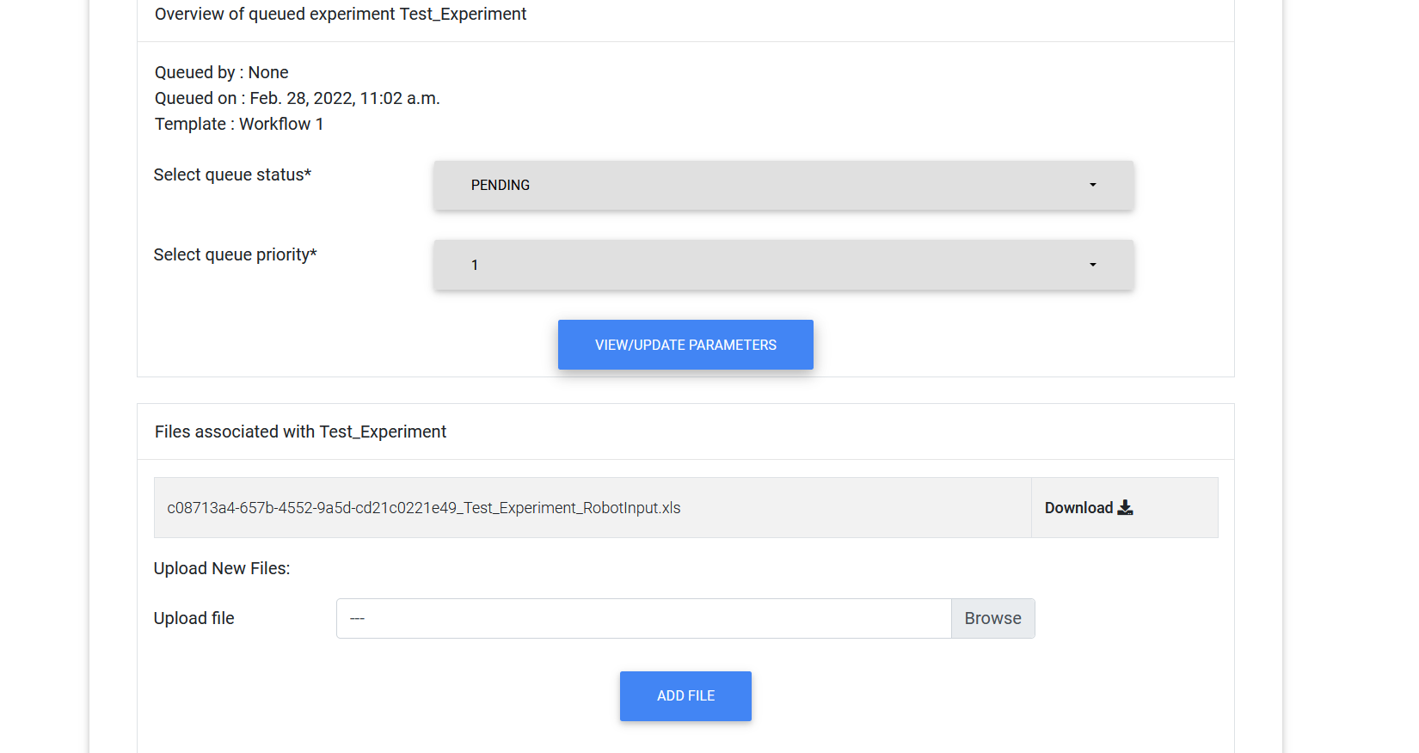

The experiment detail editor provides an overview of an experiment instance and the means to update any incorrect values within that experiment. Within this screen you can view the current status of the experiment, parameter information, and associated edocuments. The first section in the experiment detail editor provides an overview that allows the user to select the priority and update the status of the experiment. Any changes to this section needs to be submitted using the “Update Experiment” button at the bottom of the page. The button below the queue priority, View/Update Parameters, allows a user to update experiment parameters. Selecting this button will redirect you to a form similar to the image below. Each parameter associated with the experiment can have its nominal and actual values bulk updated by inserting the new values and selecting “Update Parameters” at the bottom of the page. Once the form is processed you will be redirected to the experiment details page once again.

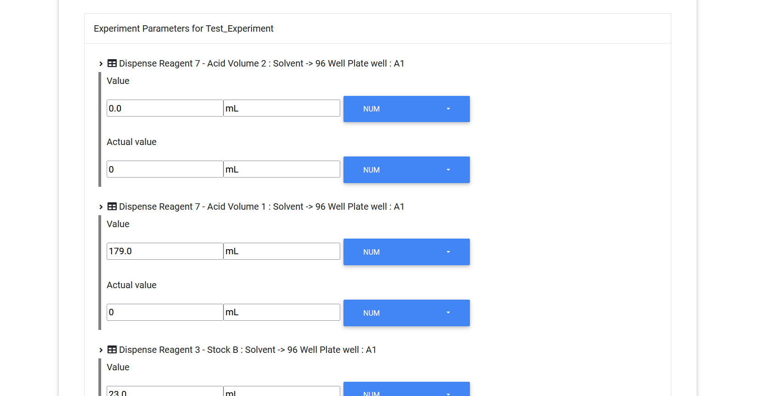

Below the parameter update button is a section that allows a user to upload and view files associated with the experiment. To download and view a file that exists on the system simply click the “Download” button to the right of each edocument. To upload a file select the “Browse” button and select the corresponding file in the file explorer. Once that file is selected click the “Add File” button at the bottom of the page.

## **9. Escalation**

Escalation is a web application developed by TwoSix Labs that generates graphical representation of data that can be found within ESCALATE. Escalation has its own documentation and working examples provided by TwoSix Labs located [here](https://github.com/twosixlabs/Escalation).

## **10. References**

Below are a list of useful external references:

* [Escalate v3 General Readme](https://github.com/darkreactions/ESCALATE/blob/master/escalate/README.md)
* [Escalate v3 Technical Readme](https://github.com/darkreactions/ESCALATE/blob/master/escalate/TECHNICAL.md)
* [Escalate v3 Data Model Readme](https://github.com/darkreactions/ESCALATE/blob/master/data_model/README.md)
* [Escalation Documentation and working examples](https://github.com/twosixlabs/Escalation)